

Requirements Gathering

Date: 19-12-2024



**1. Project Overview:**

Rambutan Warehouse is a cutting-edge online platform designed to enhance the sale and distribution of rambutan fruits and related products. By incorporating advanced tools and technologies, it provides an integrated space for farmers to list their produce, for wholesale buyers to make bulk purchases, and for regular users to explore and buy fresh and processed rambutan products. The platform’s intelligent features aim to streamline operations and promote sustainable growth within the rambutan trade.



**2. System Scope:**

The Rambutan Warehouse system is a comprehensive e-commerce solution tailored specifically for the rambutan industry. It supports real-time transactions, inventory management, and smart tools like image detection and product recommendations to improve user experience and ensure quality control.



**3. Target Audience:**

The primary target audience includes:

* Farmers: For listing and managing rambutan products.
* Wholesale Buyers: For placing and managing bulk orders.
* Regular Consumers: For purchasing fresh and processed rambutan goods.
* Platform Administrators: For overseeing platform operations and resolving issues.



**4. Modules:**

* + Allows farmers to register, list their rambutan produce, upload product images, and manage inventory.



Farmer Management Module

* + Provides image verification to ensure uploaded images correspond to rambutan fruits.
  + Tracks sales and generates insights on pricing and demand.
* 



Wholesale Buyer Module

* Enables bulk orders, price negotiation tools, and optimized delivery scheduling.
* Includes predictive analytics for inventory planning.
* 



Product Management Module

* Handles listing and categorization of rambutan varieties and processed products.
* Provides AI-driven personalized recommendations for all users.
* 



User Authentication Module

* Manages user registration, secure login, and role-based access control.
* 



Payment Processing Module

* Facilitates secure transactions using an encrypted payment gateway.
* 



Administrator Module

* Provides tools for platform oversight, user management, and analytics-driven insights.
* 



Recommendation System

* Suggests products based on user preferences, past purchases, and trends.



**5. User Roles:**

* List and manage rambutan products.



Farmers

* Track inventory and monitor sales.
* Use image verification tools to ensure product authenticity.
* 



Wholesale Buyers

* Place and manage bulk orders.
* Negotiate prices with farmers using smart tools.
* Schedule and track deliveries.
* 



Customers

* Access fresh rambutan and processed products.
* Receive personalized product recommendations.
* 



Administrator

* Oversee platform operations, resolve issues, and ensure compliance with system policies.



6. System Ownership:

The Rambutan Warehouse system is owned and operated by an organization dedicated to promoting the rambutan trade. It aims to empower farmers, provide quality assurance to buyers, and expand the market reach for rambutan products.



7. Industry/Domain:

The platform operates within the agriculture and e-commerce domain, focusing on rambutan trade, including fresh produce and its derivatives.



8. Tools and Technologies:

* Frontend: HTML, CSS, and JavaScript frameworks for responsive and user-friendly interfaces.
* Backend: Django for efficient data management and API integration.
* Database: SQLite is used.
* Machine Learning:

-Image detection to verify product authenticity.

- Recommendation engines for personalized user experiences.

* Payment Gateway: Secure and encrypted transaction handling.



9. Data Collection Contacts:

* Shibu Thomas - Farmer – 9526025052
* Tony - Agriculture Officer – 9447324332

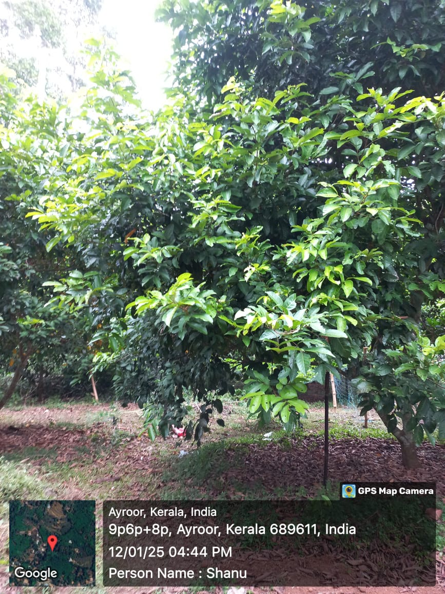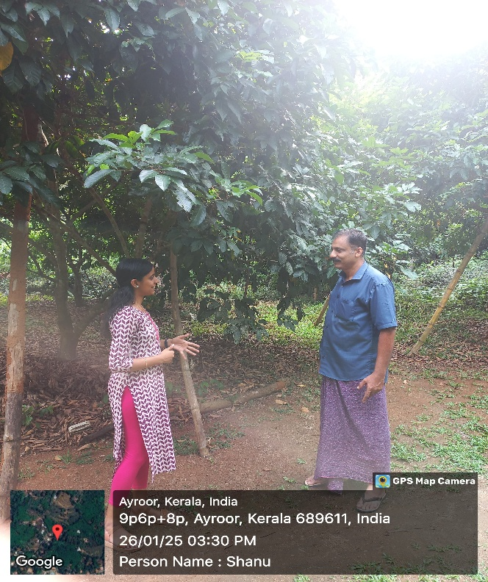



**10. Questionnaire for Data Collection:**

1. What challenges do farmers face in selling rambutan?

Farmers often face challenges such as fluctuating market prices, limited access to buyers, and difficulties in transporting their produce to marketplaces. They may also struggle with marketing their products and reaching a broader audience. Additionally, the perishability of rambutan makes it crucial to sell the produce quickly, adding pressure to find buyers promptly.

1. How do wholesale buyers typically purchase rambutan?

Wholesale buyers usually purchase rambutan in large quantities directly from farmers or through intermediaries. They often prefer bulk purchases to get better pricing and may negotiate based on the quality and size of the harvest. Buyers typically require consistent supply and may establish long-term relationships with trusted farmers to ensure a steady flow of produce.

1. What rambutan products are most popular among consumers?

Rambutan products that are popular among consumers include jams, pickles, ice cream, wine, and juice. These processed products offer convenience and extended shelf life compared to fresh rambutan. The demand for such products is often driven by their exotic flavor, nutritional value, and versatility in culinary uses.

1. What pricing model is preferred by farmers?

Farmers generally prefer a pricing model that guarantees fair compensation for their produce, often favoring direct sales or minimum price guarantees. They might also appreciate the ability to participate in bidding or auction systems that allow them to potentially earn higher prices based on demand. Transparent pricing mechanisms that reflect market conditions and production costs are highly valued.

1. How do buyers prefer to schedule deliveries?

Buyers typically prefer flexible delivery schedules that can be tailored to their needs, with options for both immediate and scheduled deliveries. They often seek timely deliveries that align with their inventory and sales cycles, and appreciate the ability to track and manage their orders online. Reliability in delivery timing is crucial to maintaining freshness, especially for perishable goods like rambutan.

1. How do buyers prefer to communicate with sellers?

Buyers generally prefer to communicate with sellers through direct phone calls, messaging apps like WhatsApp, or emails. These methods allow for quick and personalized interactions, enabling buyers to ask specific questions, negotiate prices, and arrange delivery details. In some cases, buyers may also meet sellers in person at markets or through established networks to discuss transactions but these are time consuming process.

1. What are the most critical features for an online agricultural marketplace?

Key features include user-friendly interfaces for both buyers and sellers, secure payment and transaction processing, real-time inventory tracking, and robust search and filter options for products. Additionally, transparent pricing, quality assurance mechanisms, and reliable logistics and delivery options are critical to ensure customer satisfaction. Support for multiple languages and currencies can also enhance accessibility and reach.

1. How do farmers track their inventory?

Farmers typically track their inventory using manual records, spreadsheets, or agricultural management software that allows them to monitor their stock levels, sales, and harvest schedules. Some may also use mobile apps or integrated systems provided by agricultural marketplaces to manage inventory in real-time.

1. What support do farmers need for marketing their produce?

Farmers often need assistance with digital marketing, including social media promotion, online sales platforms, and content creation to showcase their produce. They may also benefit from training on branding, packaging, and reaching new markets. Access to market data and insights can help them make informed decisions about pricing and distribution strategies.

1. How important is the ability to compare prices and quality from different sellers when purchasing rambutan?

Buyers prefer platforms that offer transparency in pricing and quality. Knowing that I can compare different sellers before making a purchase gives me confidence that I'm making the right choice.

**Conclusion**

The requirements gathering process for Rambutan Warehouse has identified the key functionalities and technologies necessary to create a robust and user-friendly platform for the rambutan trade. By addressing the needs of farmers, wholesale buyers, regular consumers, and administrators, the platform aims to bridge existing gaps in the rambutan industry. Leveraging cutting-edge tools such as machine learning for product verification and recommendations, along with secure payment systems and streamlined operations, Rambutan Warehouse sets a new benchmark in agricultural e-commerce. The insights from stakeholders and data collection provide a strong foundation for designing a system that ensures transparency, efficiency, and growth for all involved.